Practical 07:

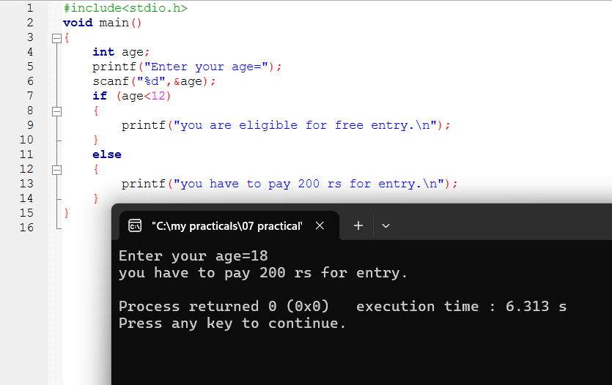

7-I,ii:

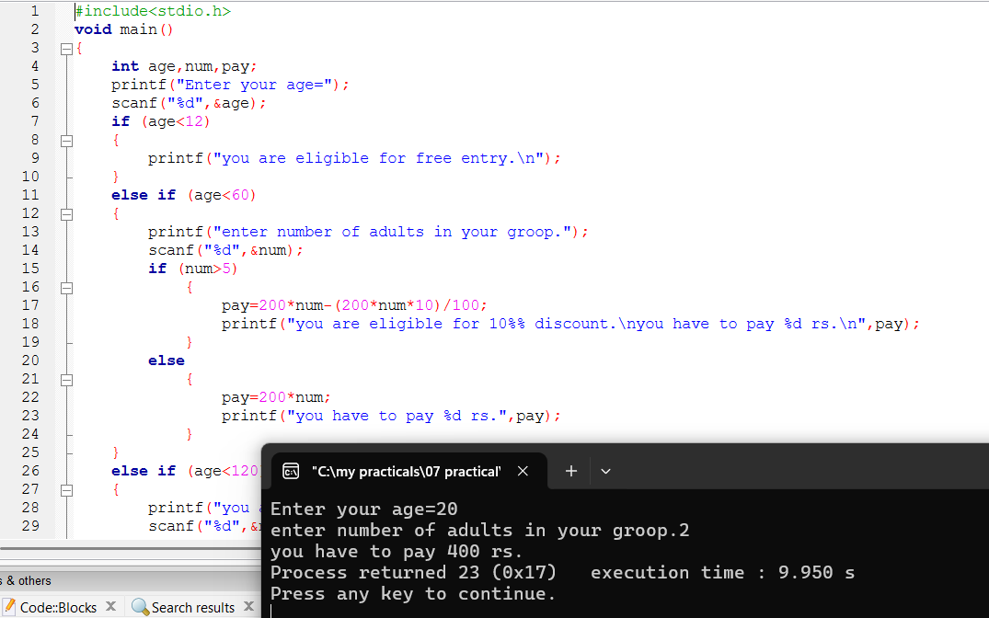

7-ii:



